1. Creating the database ‘mongo_practice.’

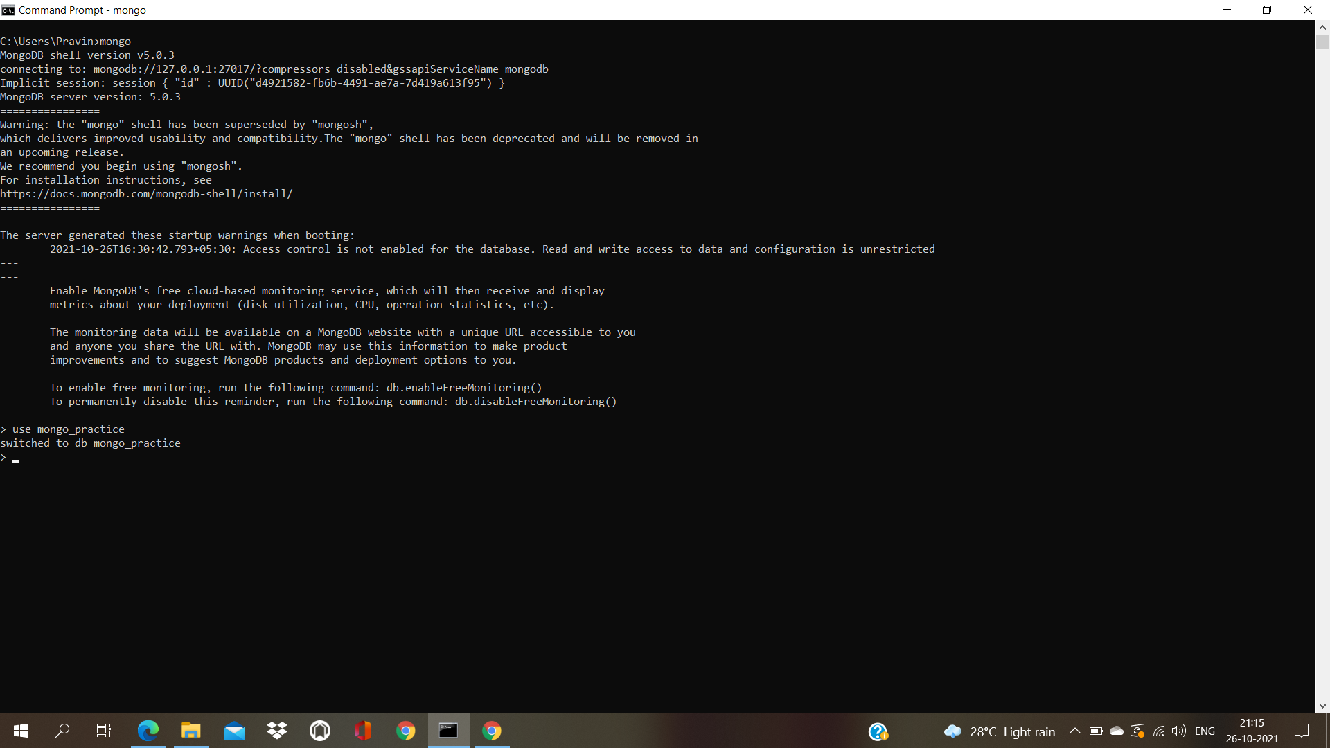

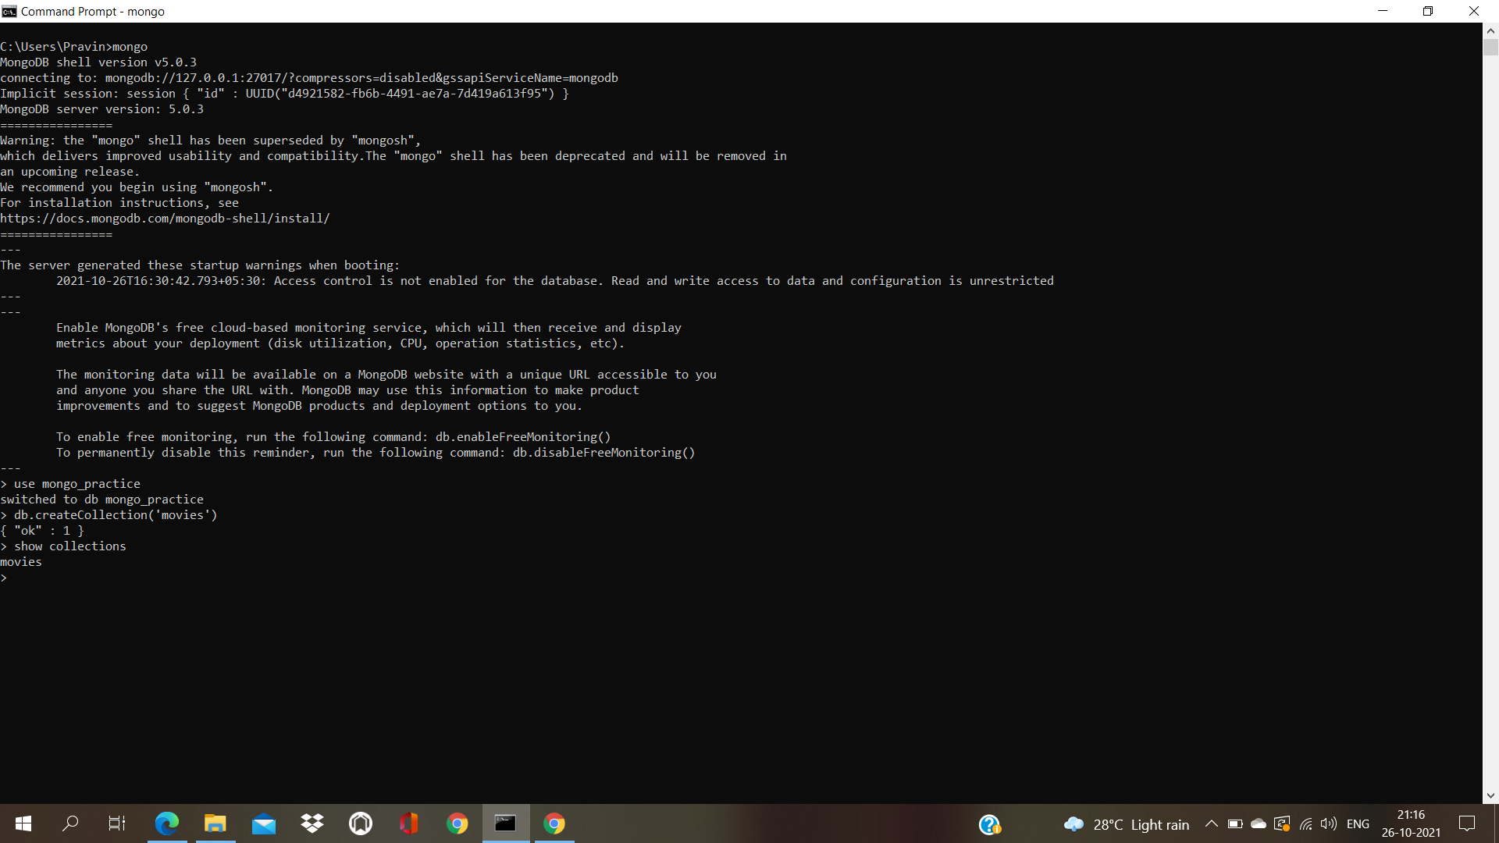2.Creating ‘movies’ collection

1. Inserting the given data

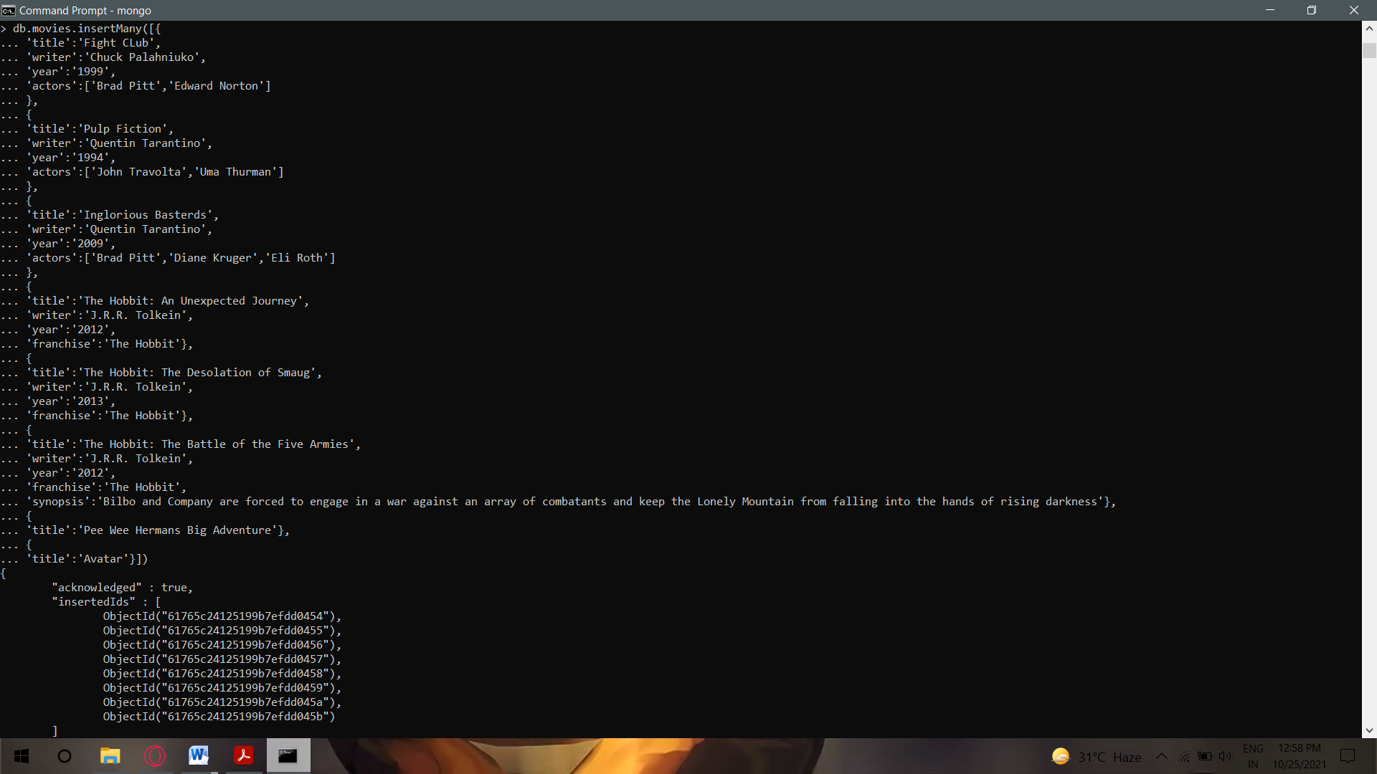3. Inserting the given data

1. 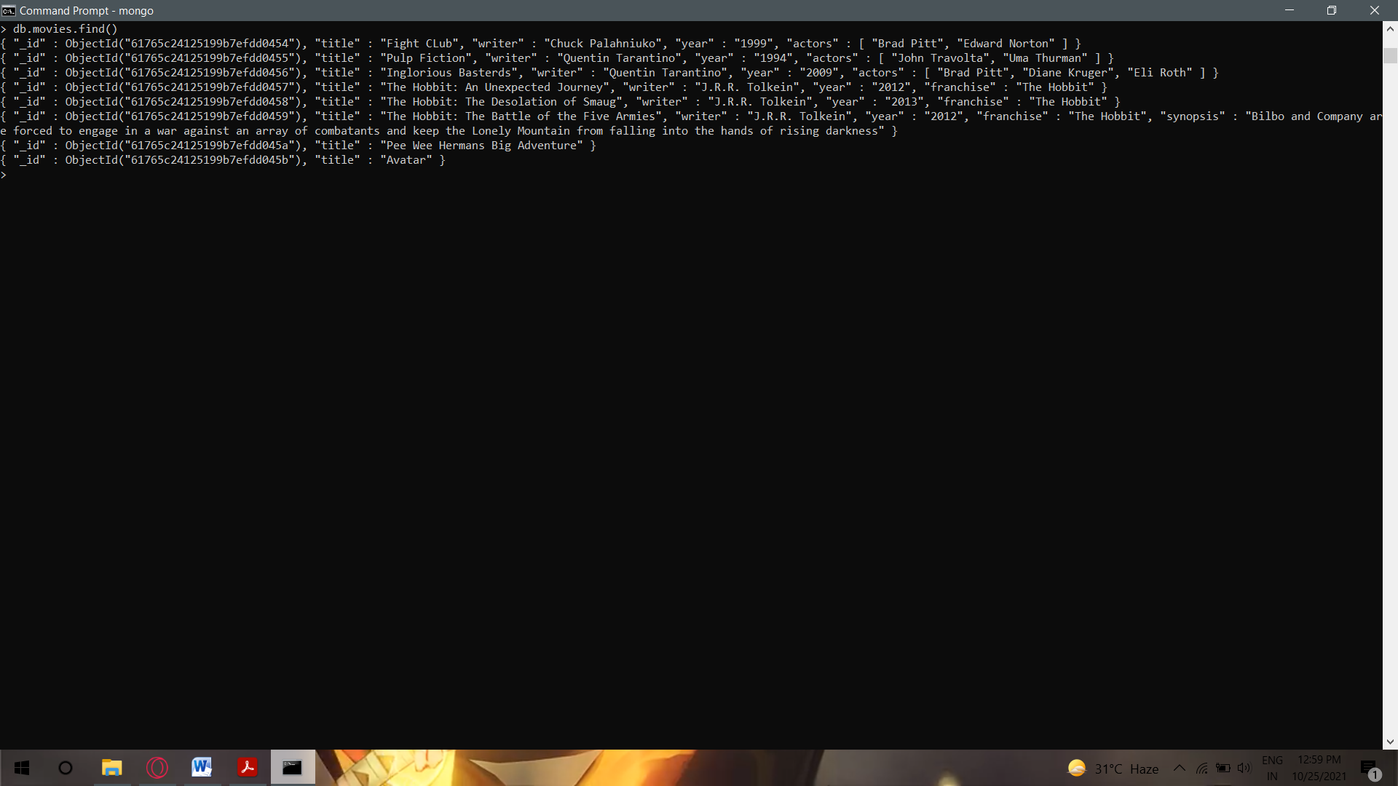Get all the documents

1. get all documents with writer set to "Quentin Tarantino"

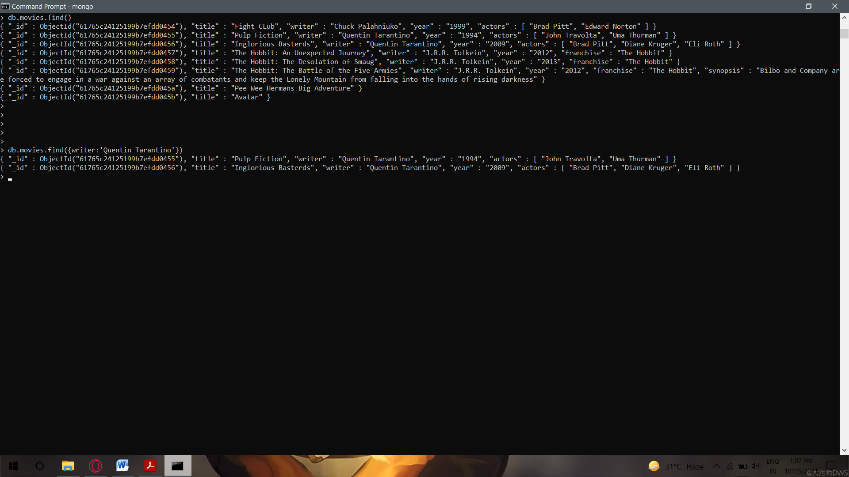

1. 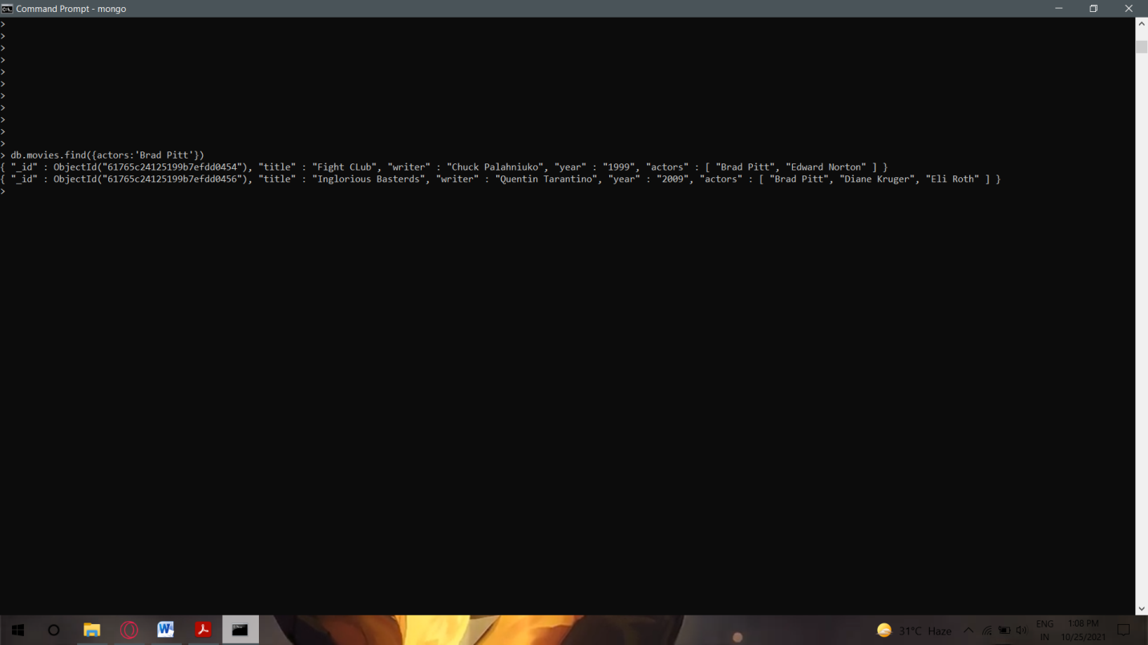get all the documents where actors include Brad Pitt
2. get all the movies with franchise set ‘The Hobbit’

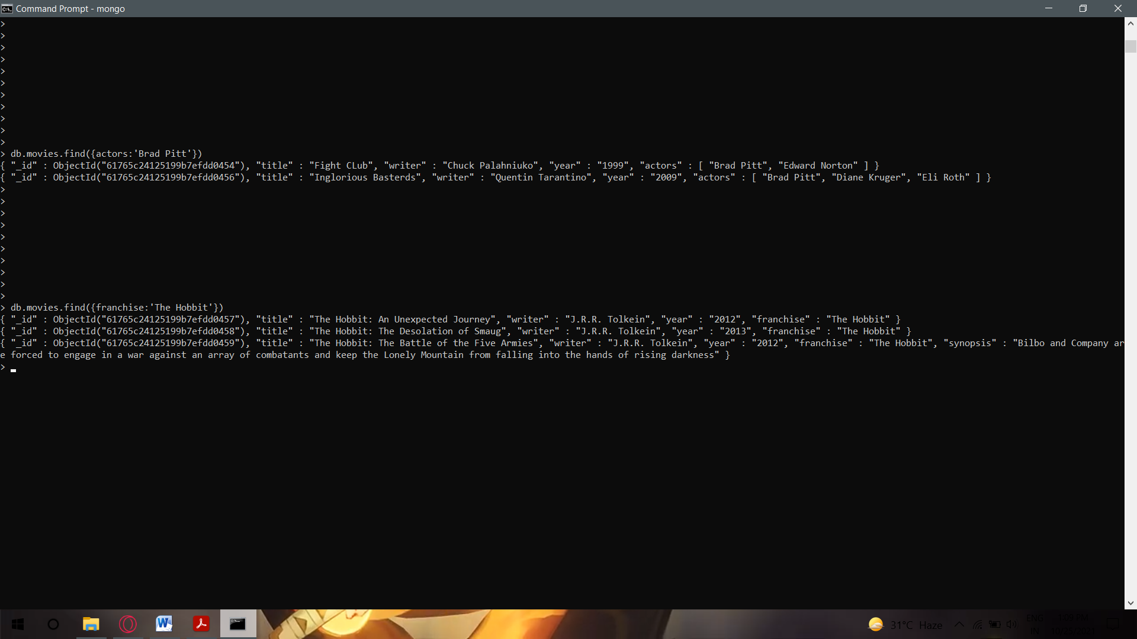

1. get all the movies released in 90’s

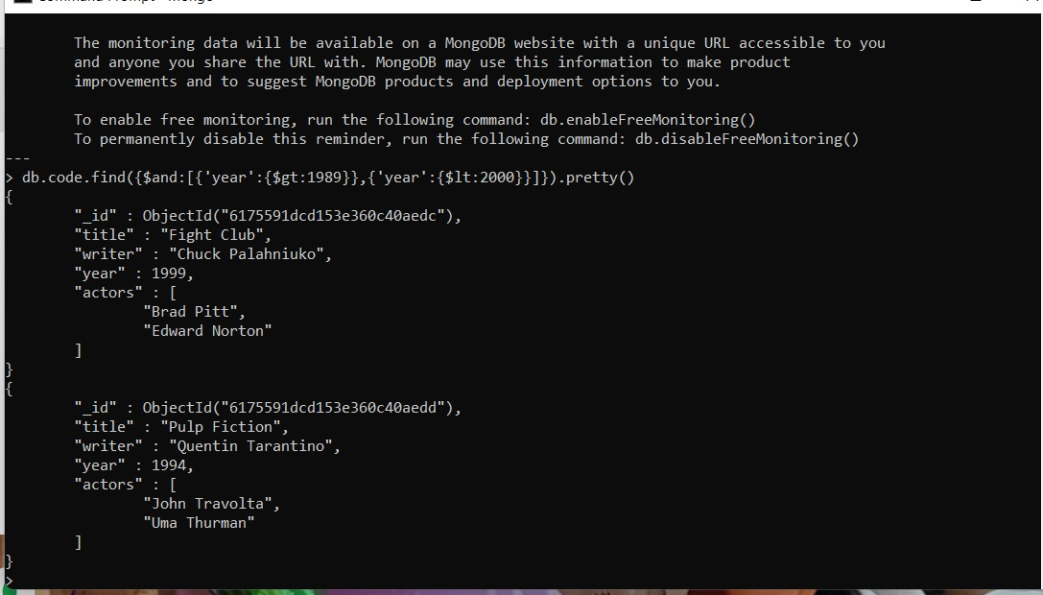

1. get all the movies released before the year 2000 or after 2010.

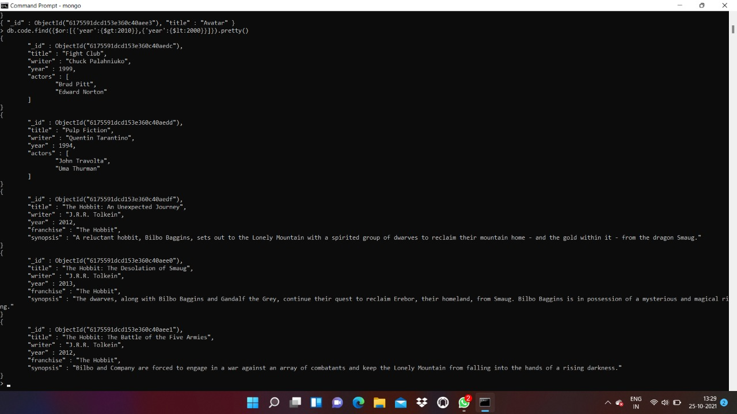

1. 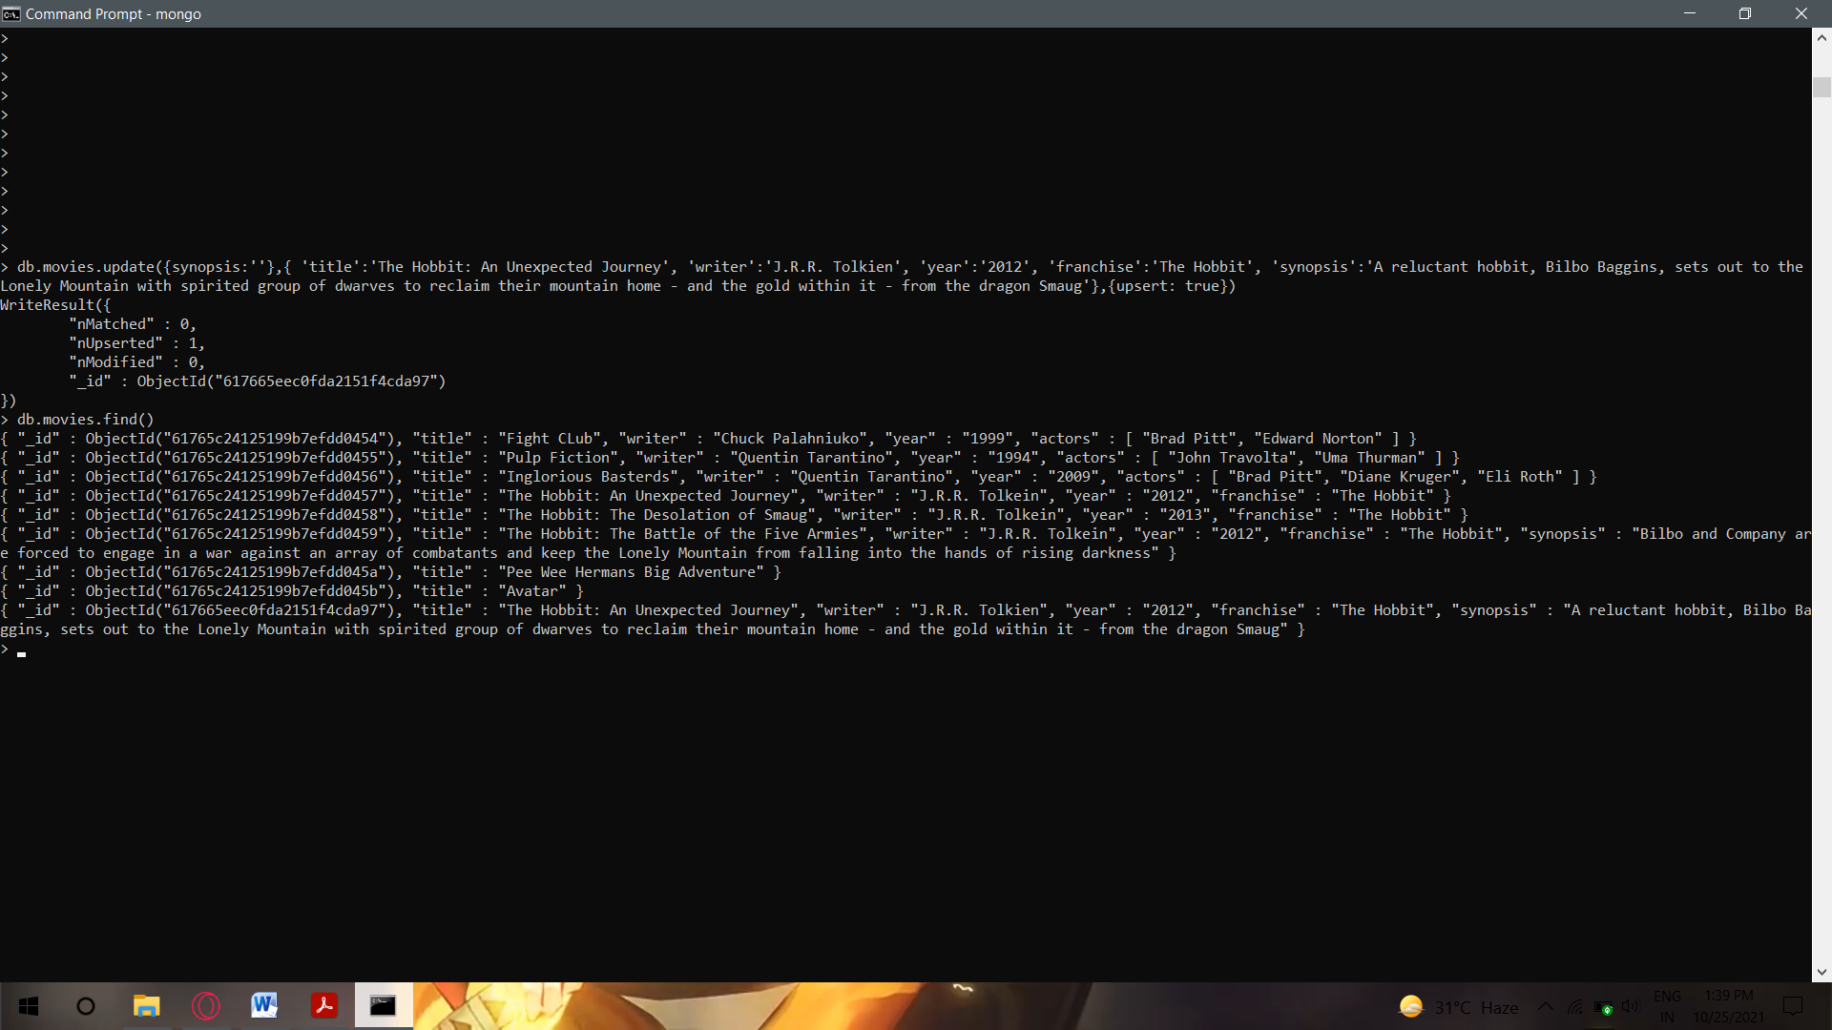add synopsis to ‘The Hobbit: An unexpected journey’
2. add synopsis to ‘The Hobbit: The Desolation of Smaug’

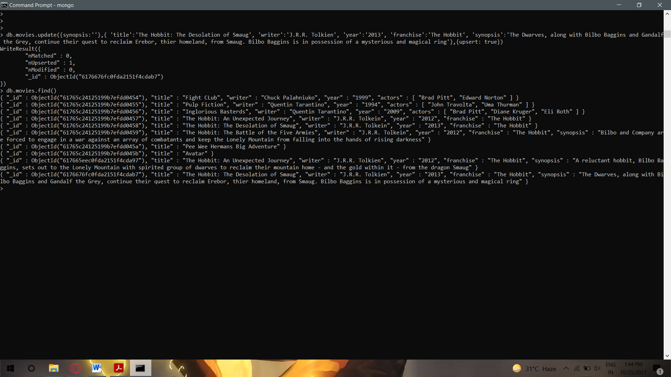

1. 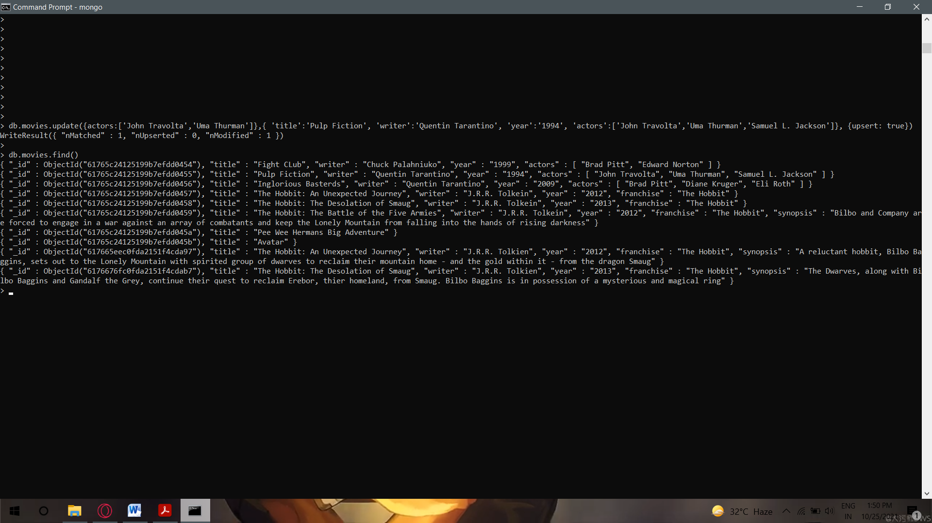add an actor named "Samuel L. Jackson" to the movie "Pulp Fiction"
2. find all the movies that have synopsis that contains the word “Bilbo”

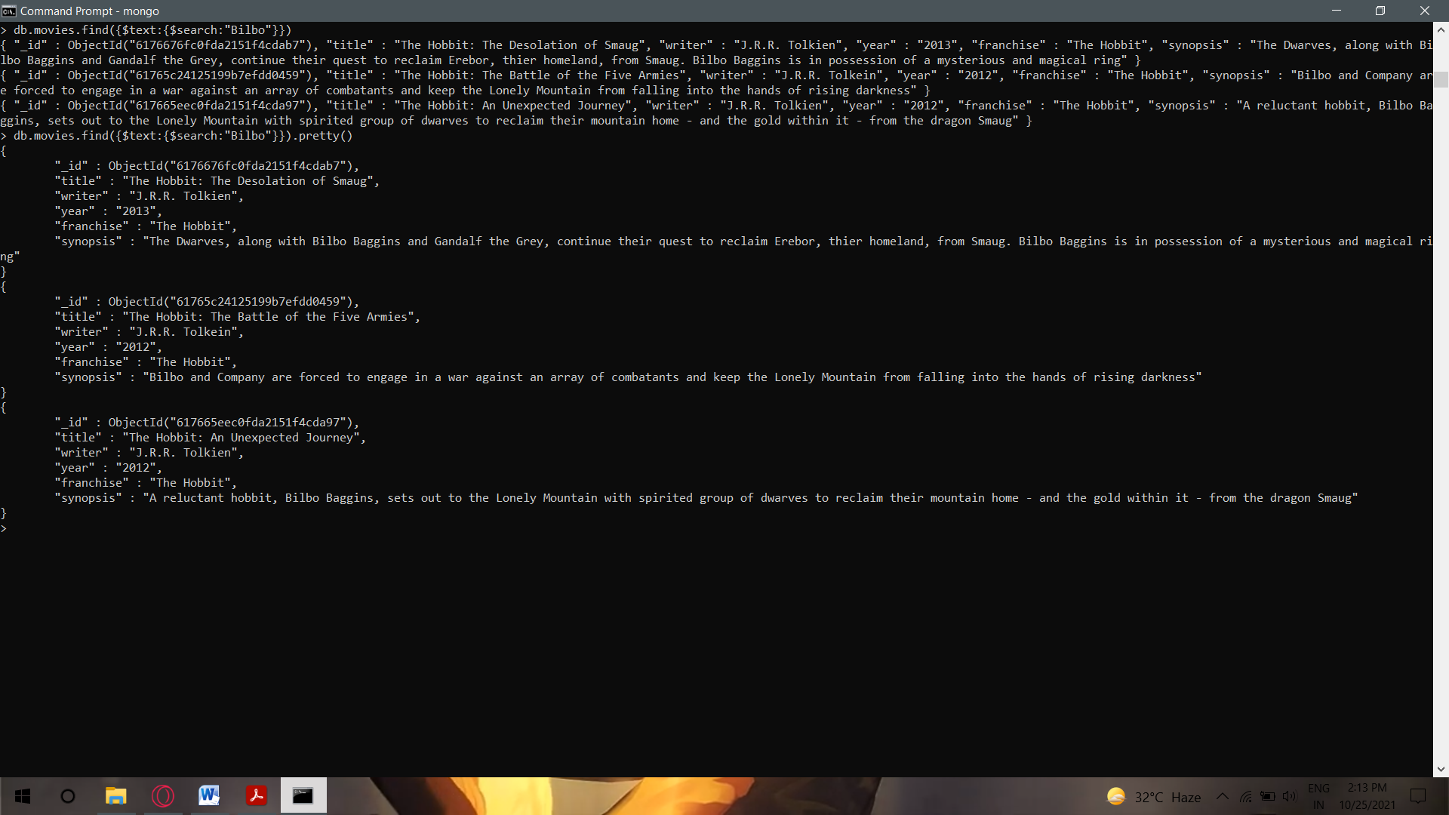

1. 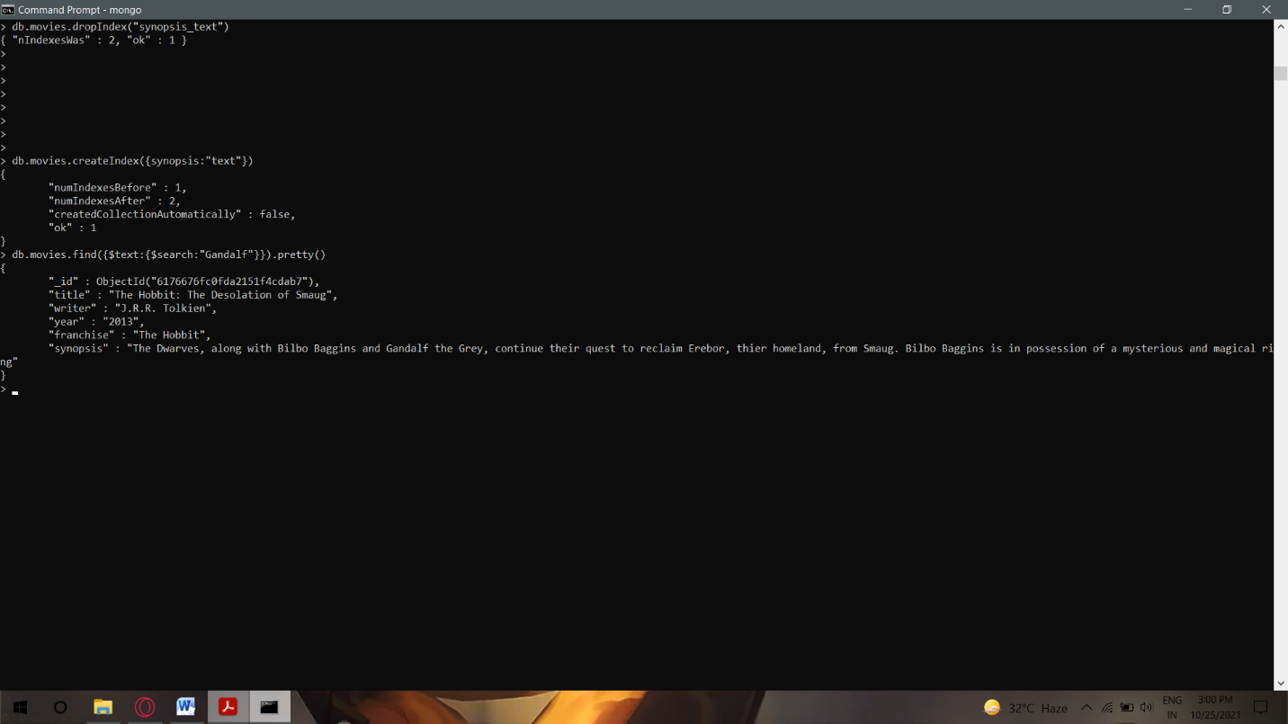find all the movies that have synopsis that contains the word “Gandalf”
2. find all movies that have a synopsis that contains the word "Bilbo" and not the word "Gandalf"

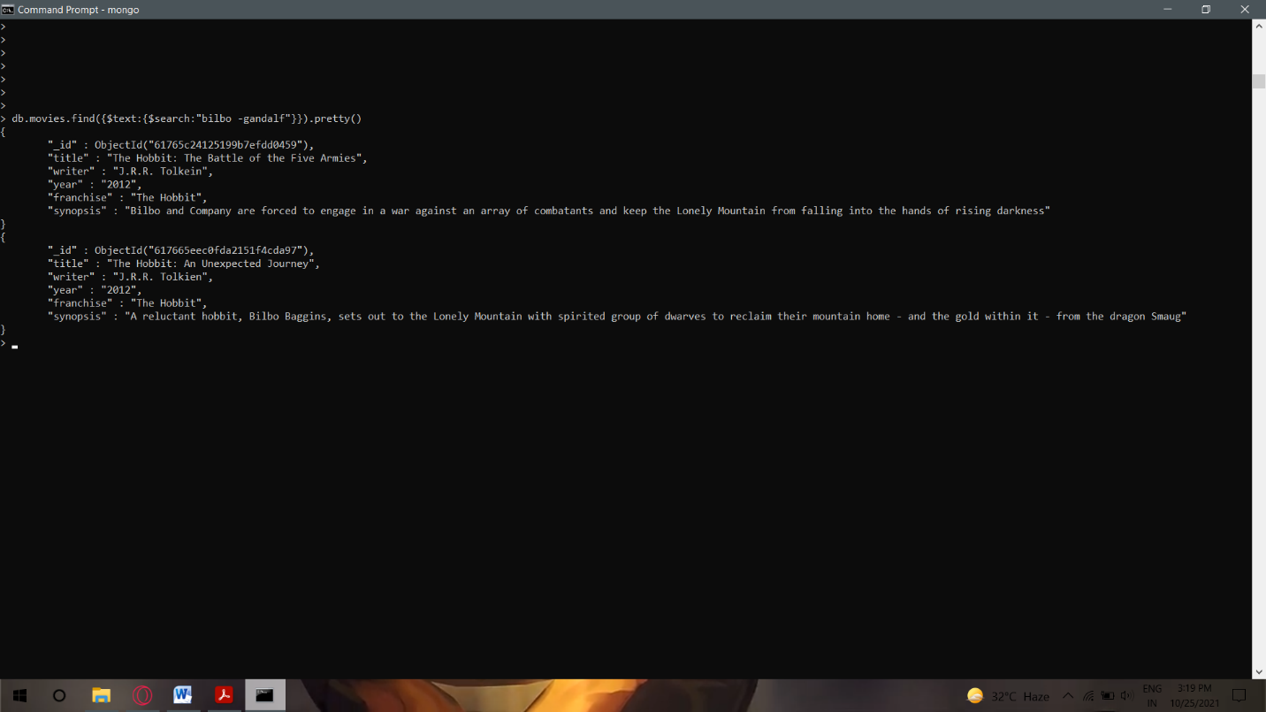

1. 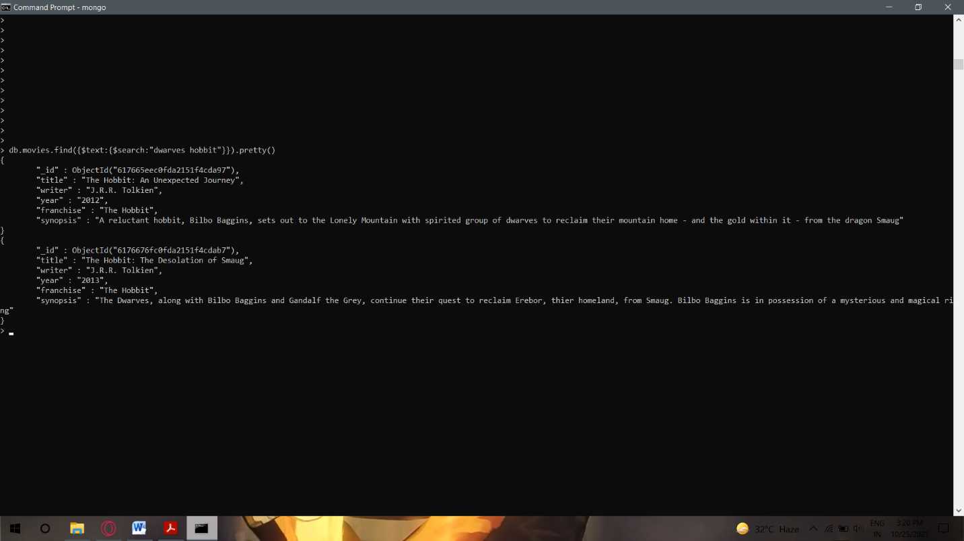find all movies that have a synopsis that contains the word "dwarves" or "hobbit"
2. 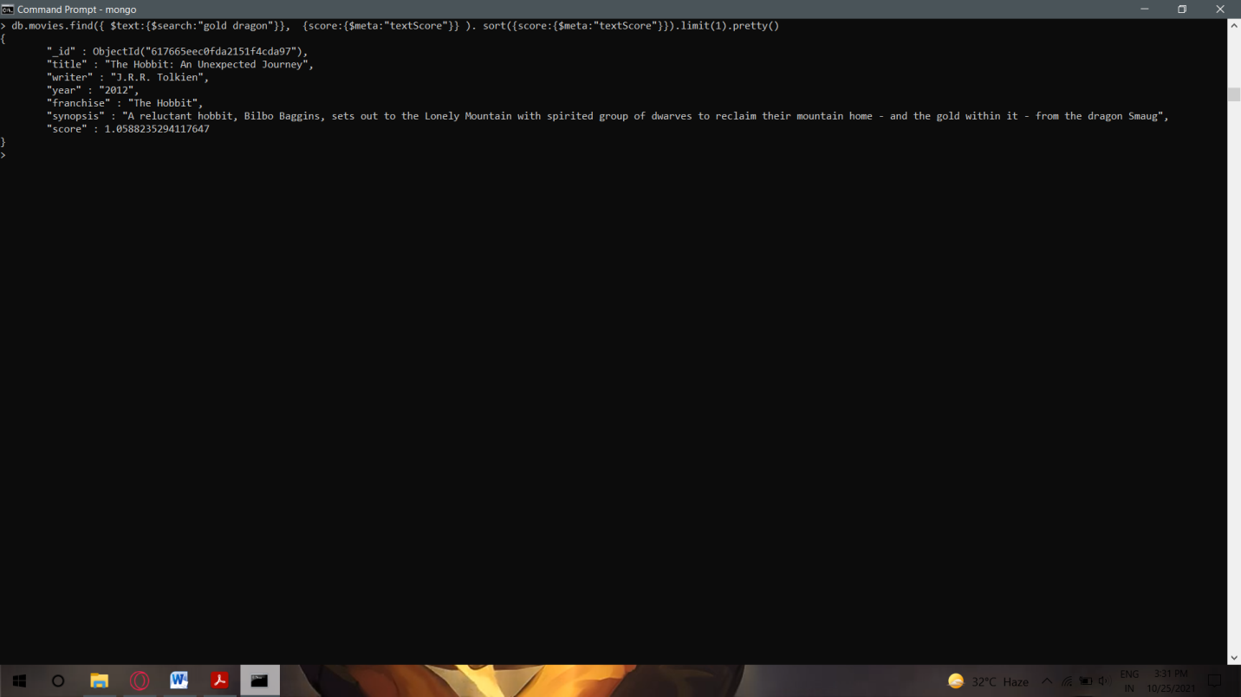find all movies that have a synopsis that contains the word "gold" and "dragon"
3. delete the movie "Pee Wee Herman's Big Adventure" delete the movie "Avatar"

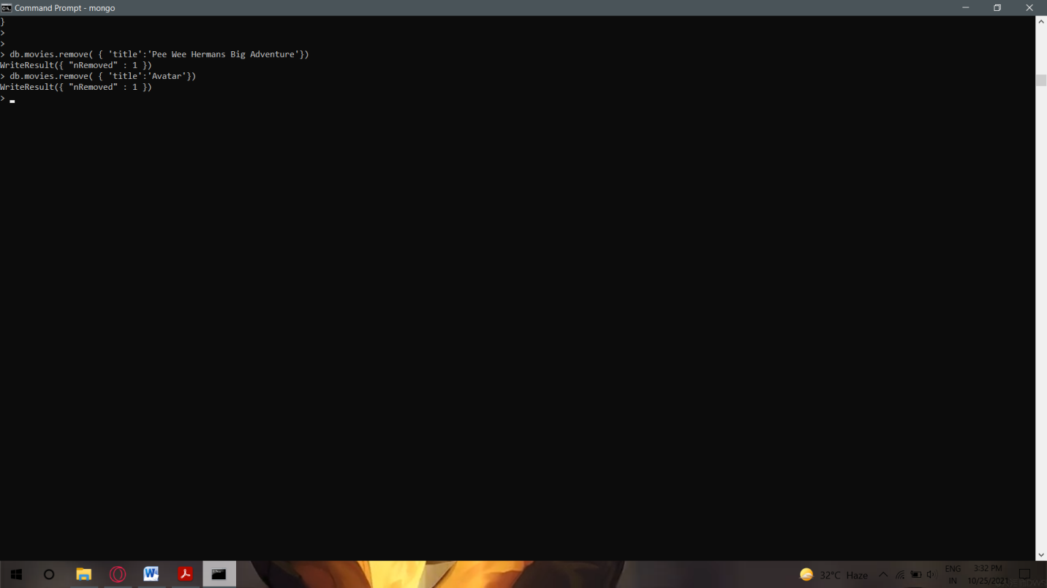

1. 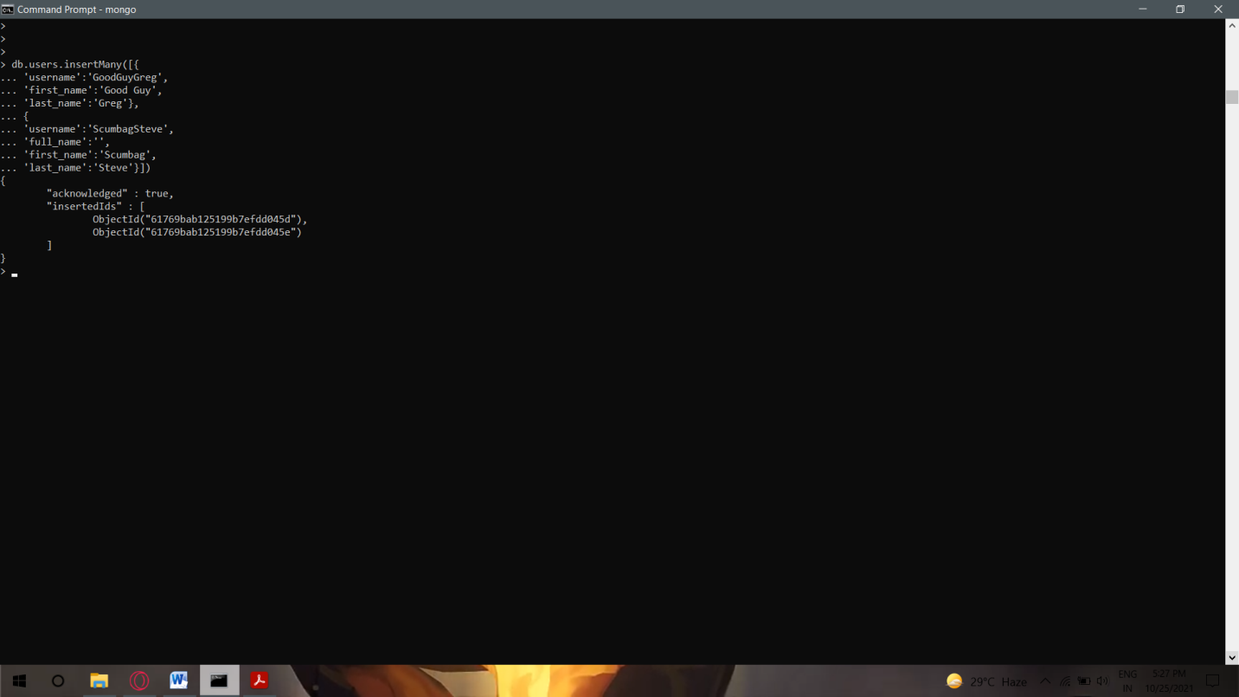Insert the following documents into a **users** collection
2. 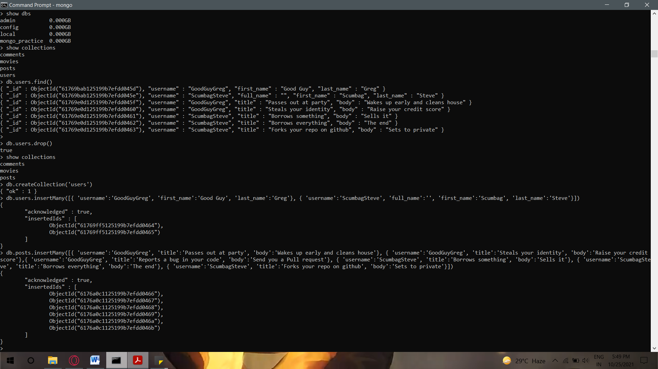Insert the following documents into a **posts** collection
3. 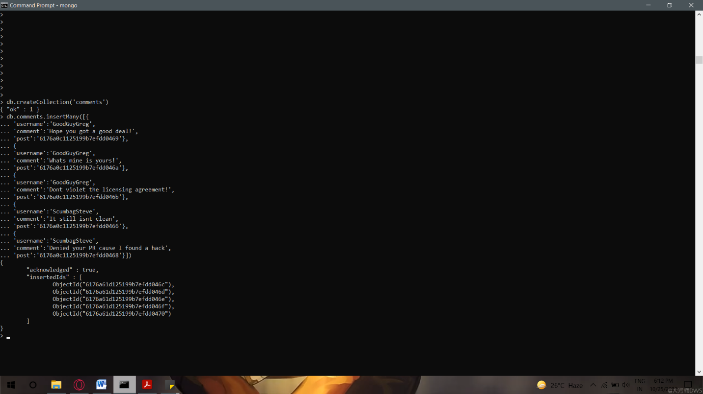Insert the following documents into a **comments** collection

1. find all users

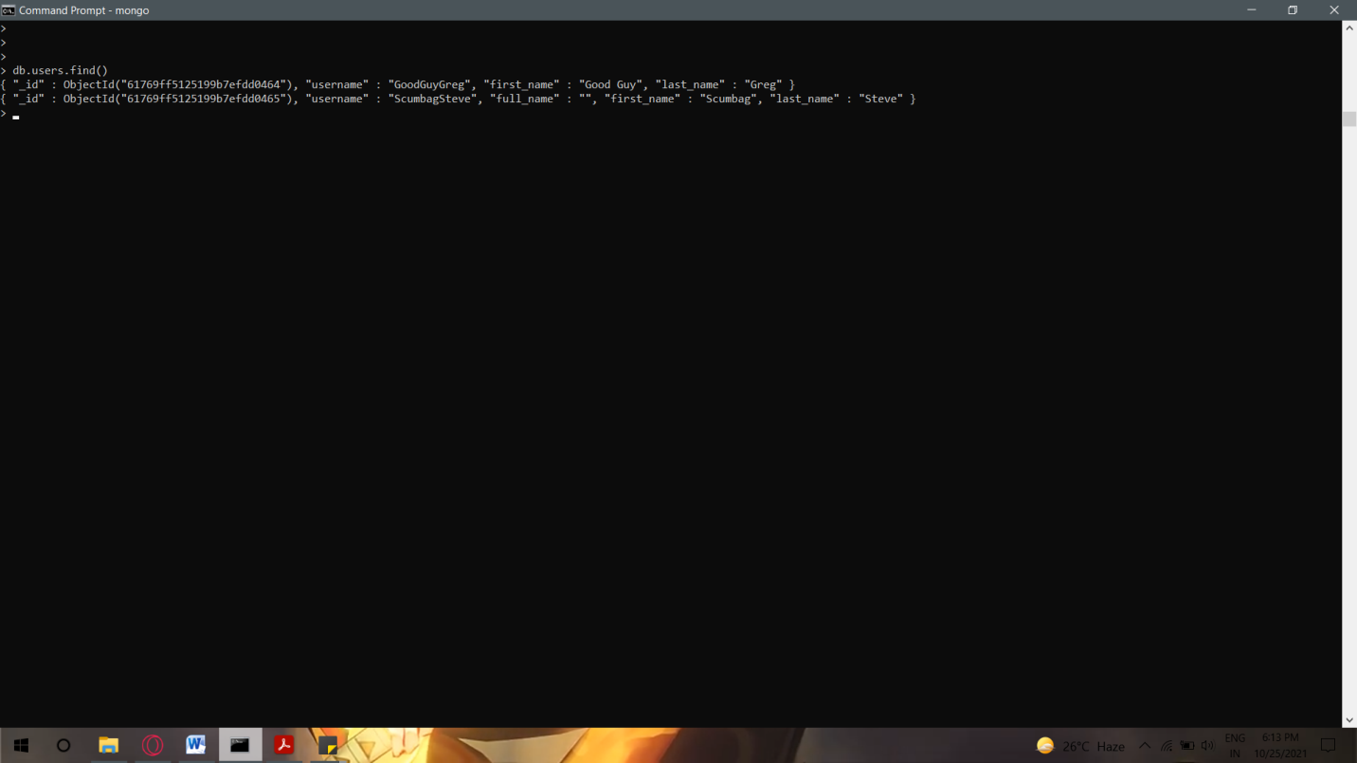

1. 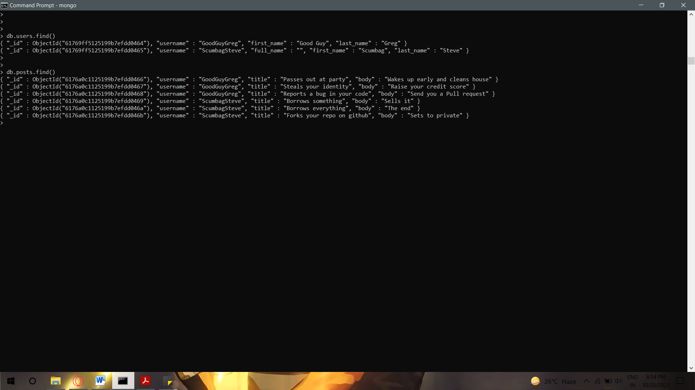find all posts

1. find all posts that was authored by "GoodGuyGreg"

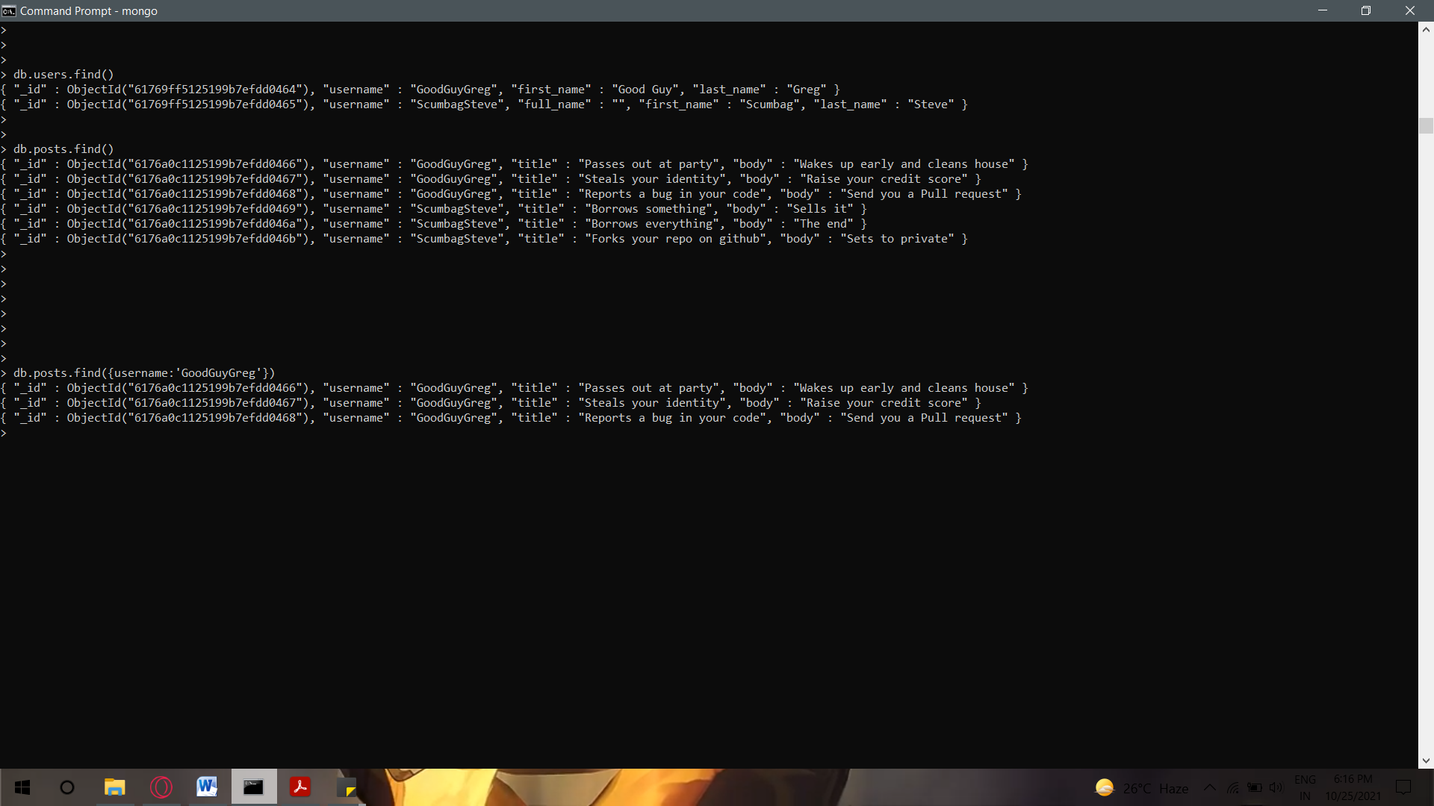

1. 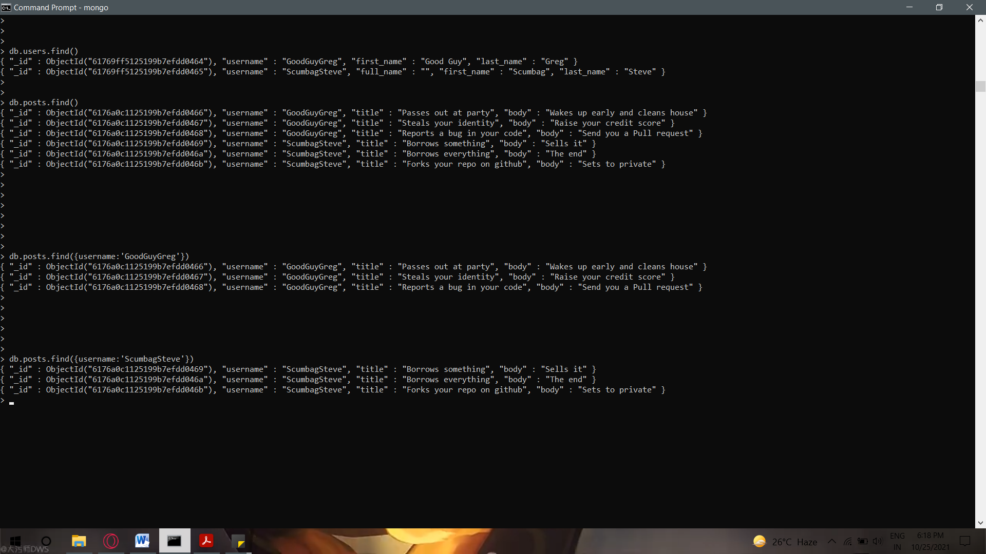find all posts that was authored by "ScumbagSteve"

1. 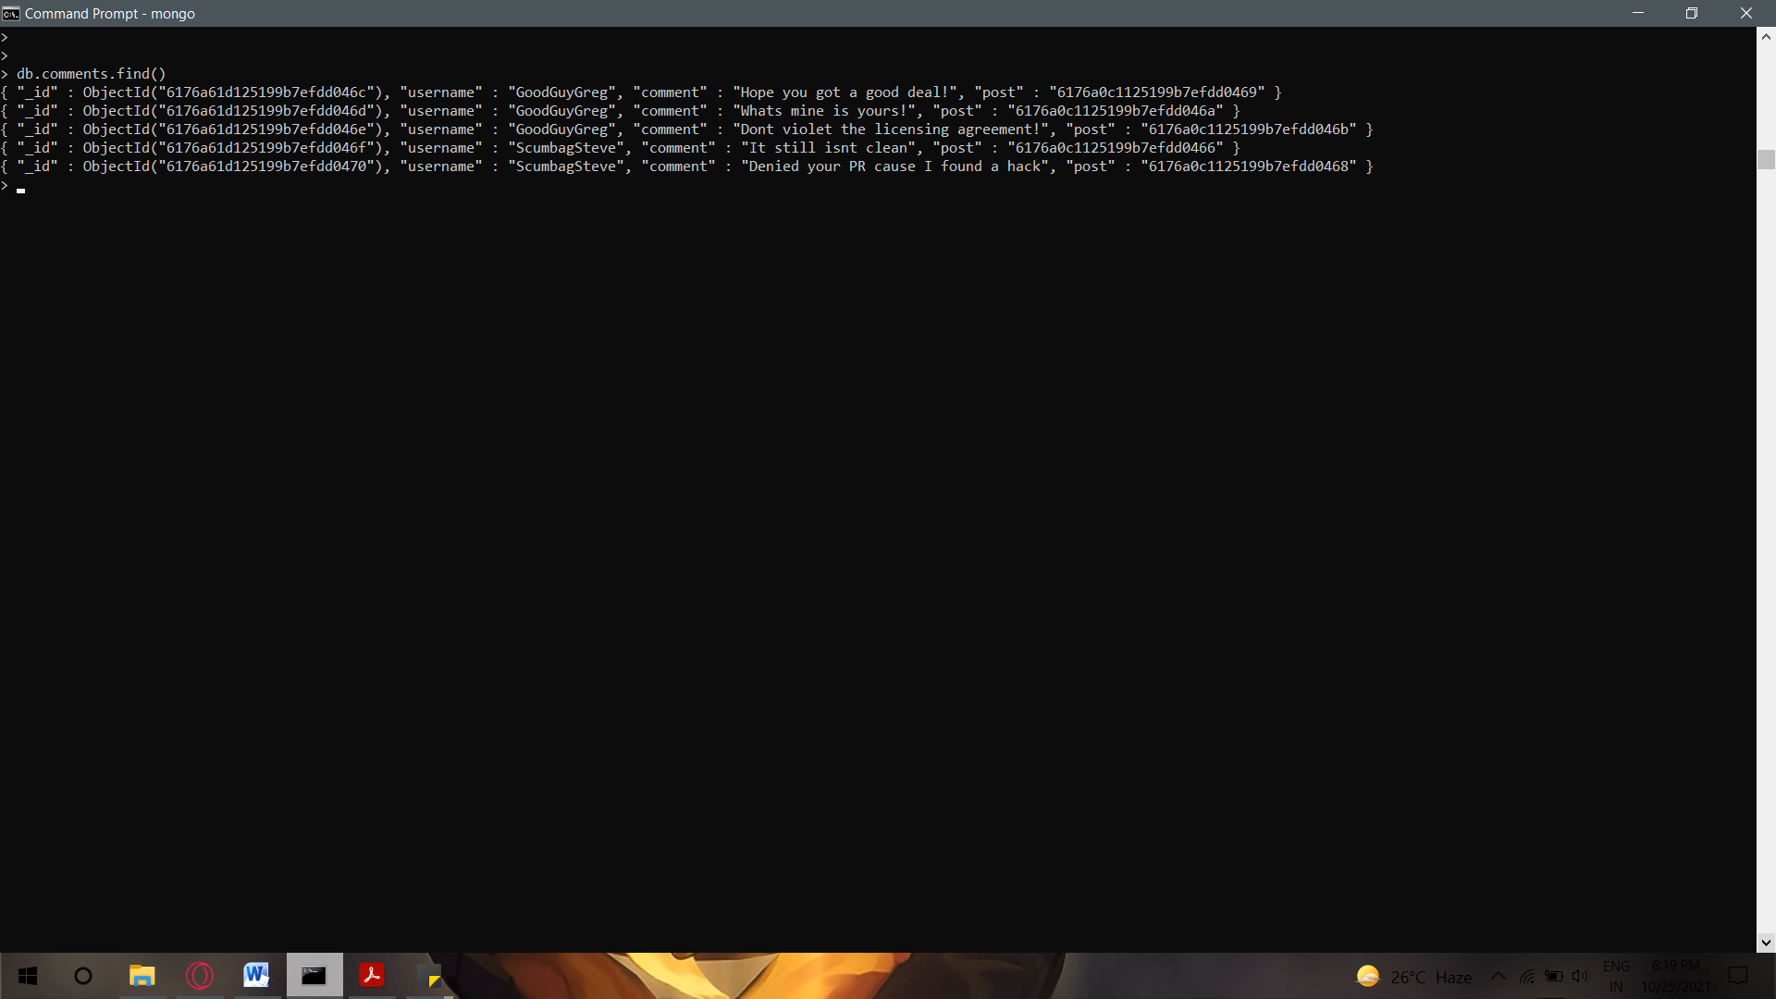find all comments

1. 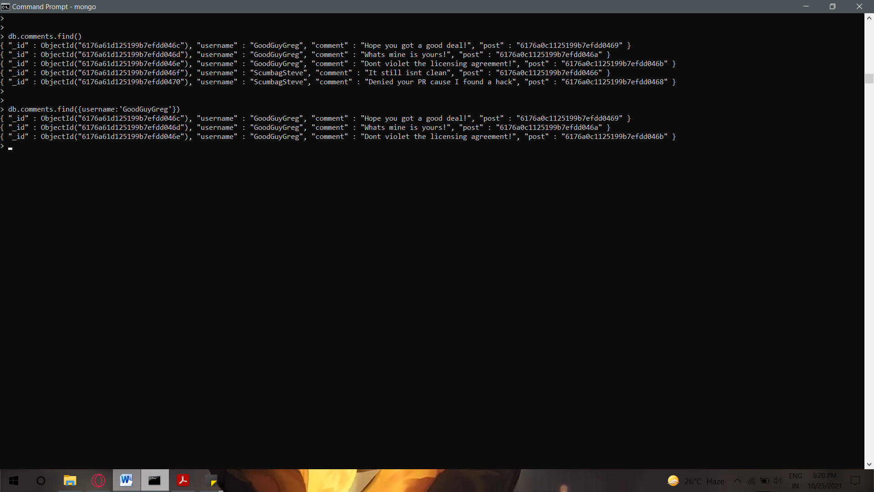find all comments that was authored by "GoodGuyGreg"
2. 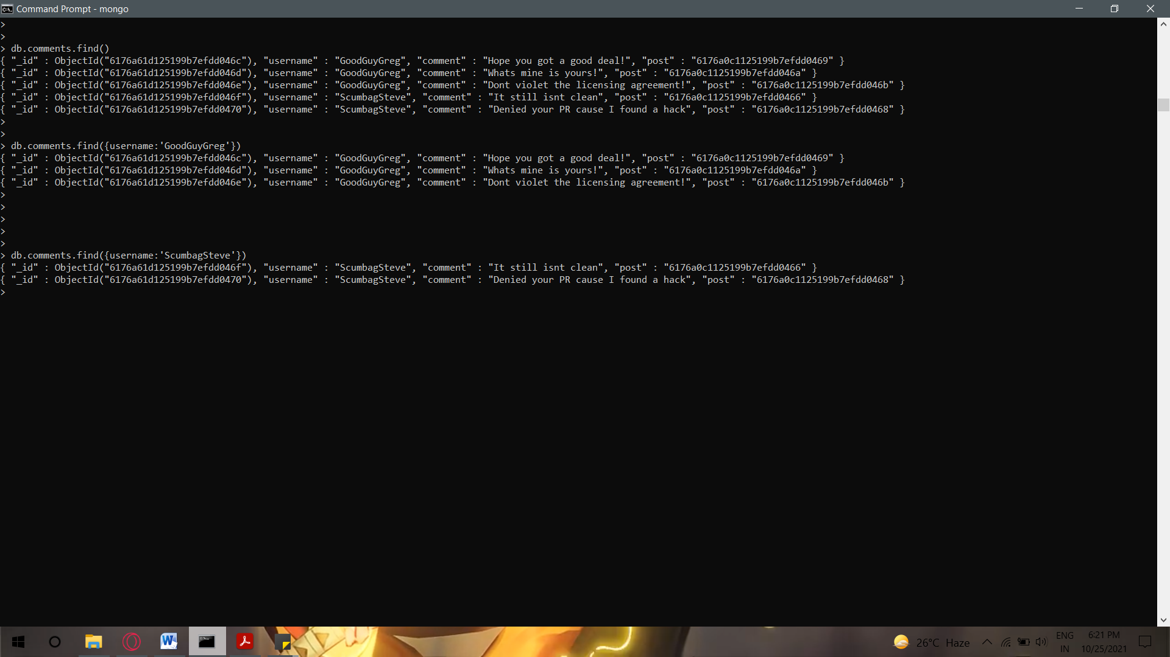find all comments that was authored by "ScumbagSteve"

1. 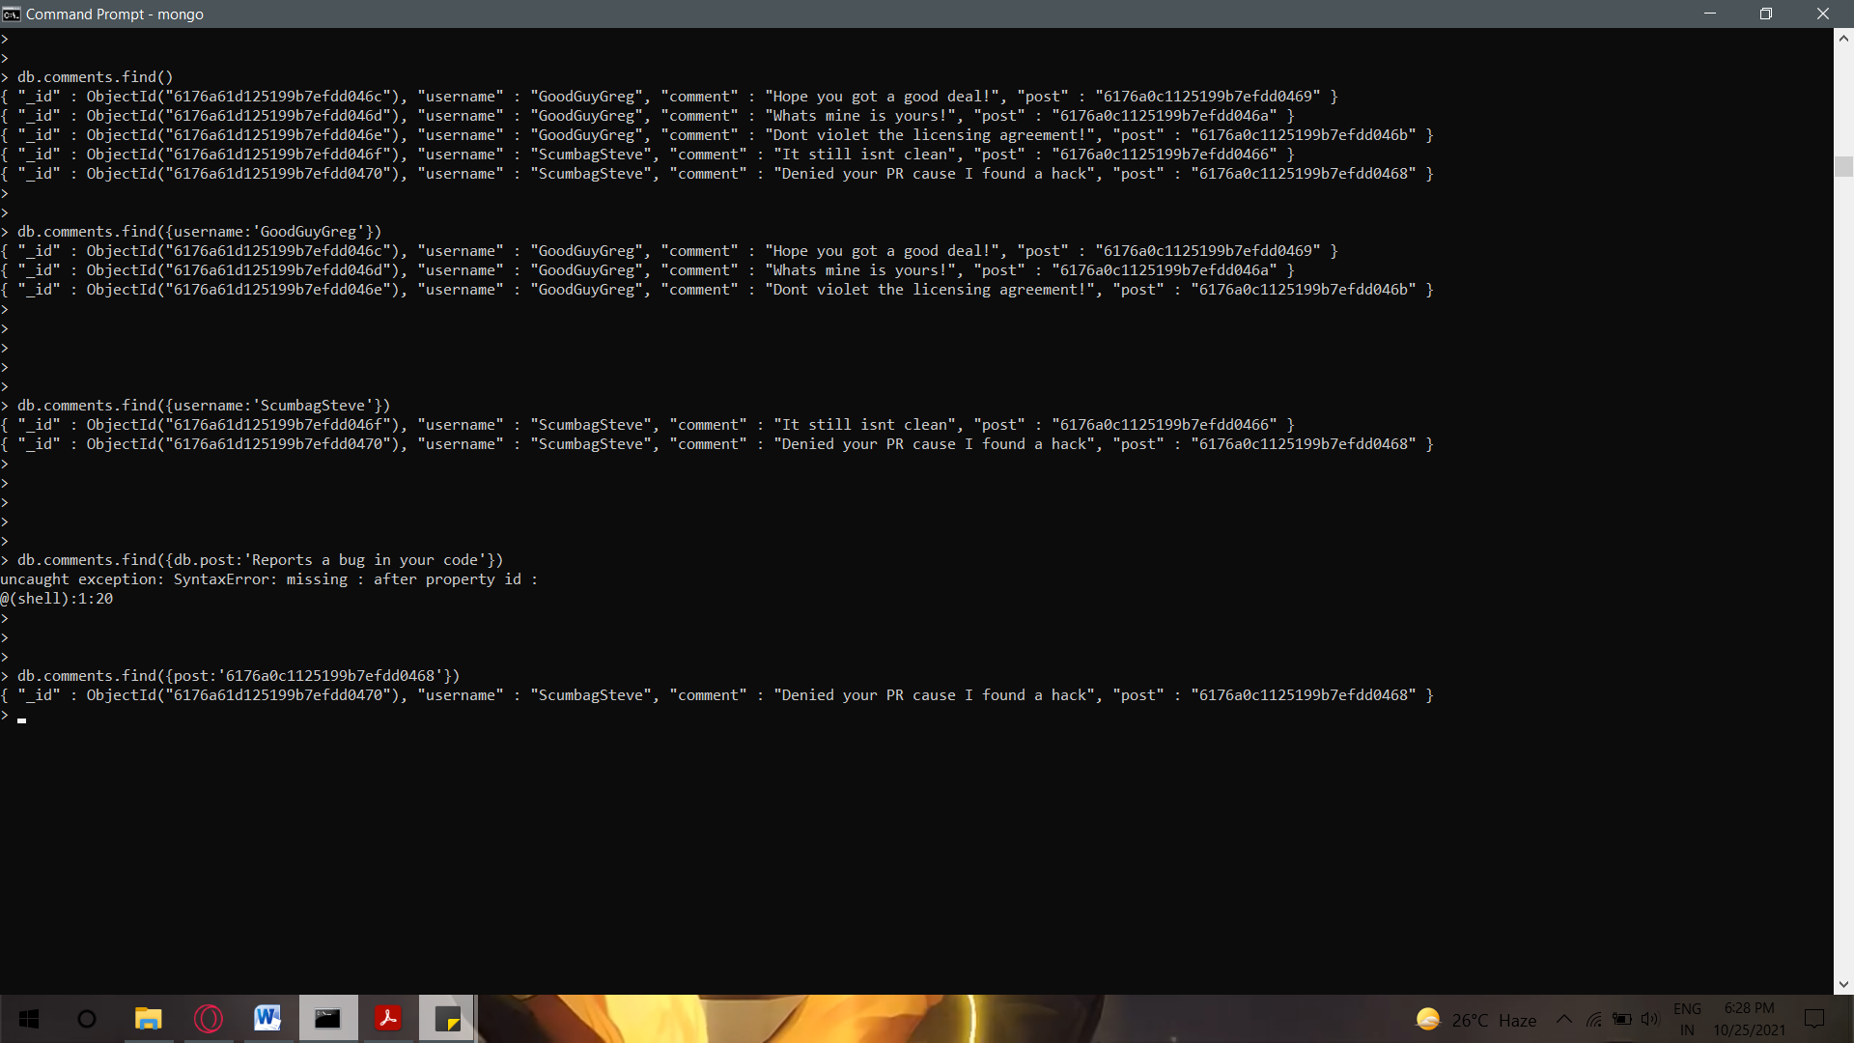find all comments belonging to the post "Reports a bug in your code"